

DESIGN, ANALYZE AND IMPLEMENT A PERSONALIZED MOVIE RECOMMENDATION SYSTEM USING A GRAPH SIMILARITY ALGORITHM
A CAPSTONE PROJECT REPORT

A Capstone Project Report submitted in partial fulfilment of the requirements for the Course of

CSA0609 - DESIGN AND ANALYSIS OF ALGORITHMS
to the award of the degree of

BACHELOR OF TECHNOLOGY
IN
ARTIFICIAL INTELLIGENCE AND DATA SCIENCE

Submitted by
A.Siva suraj sai (192425276)

Under the Supervision of
Dr. Solainayagi

SIMATS ENGINEERING
Saveetha Institute of Medical and Technical Sciences Chennai-602105

SEPTEMBER 2026

SIMATS ENGINEERING
Saveetha Institute of Medical and Technical Sciences Chennai-602105

BONAFIDE CERTIFICATE

This is to certify that the Capstone Project entitled “DESIGN, ANALYZE AND IMPLEMENT A PERSONALIZED MOVIE RECOMMENDATION SYSTEM USING A GRAPH SIMILARITY ALGORITHM” has been carried out by A.Siva suraj sai (192425276) under the supervision of Dr. Solainayagi and is submitted in partial fulfilment of the requirements for the current semester of the B. Tech Artificial Intelligence And Data Science program at Saveetha Institute of Medical and Technical Sciences, Chennai.

COURSE COORDINATOR COURSE FACULTY
Dr. Dr. F. Mary Harin Fernandez Dr. Solainayagi
Professor Professor
Department of CSE Department of CSE
SIMATS Engineering, SIMATS Engineering,
SIMATS, Chennai – 602105. SIMATS, Chennai – 602105.

SIMATS ENGINEERING
Saveetha Institute of Medical and Technical Sciences Chennai-602105

DECLARATION

We, A.Siva suraj sai (192425276), of the AI&DS , AI&ML SIMATS Engineering, Saveetha Institute of Medical and Technical Sciences, Chennai, hereby declare that the Capstone Project Work entitled “Multi-algorithm path exploration and navigation simulator” is the result of our own bonafide efforts. To the best of our knowledge, the work presented herein is original, accurate, and has been carried out in accordance with the principles of engineering ethics and academic integrity. All sources, references, data, and other materials used in the project have been appropriately acknowledged. We further declare that the data, results, analysis, and findings presented in this report have not been fabricated, falsified, or manipulated. Any external tools, software, datasets, computational resources, or AI-assisted tools used during the project have been appropriately disclosed. We confirm that all applicable ethical, academic, institutional, and professional requirements have been duly followed throughout the planning, execution, analysis, and documentation of the project.

Place: Chennai
Date:

Signature of the Students with Names
A.Siva suraj sai

SIMATS ENGINEERING
Saveetha Institute of Medical and Technical Sciences
Chennai – 602105

INDIVIDUAL CONTRIBUTION STATEMENT
(Mandatory for all team projects)

Student / Register No. | Specific Responsibilities | Design & Development | Testing & Analysis | Report Contribution | Approx. %
A. Siva Suraj Sai  192425276 | Module 1 – Movie Data Management; dataset profiling; cleaning; duplicate handling; normalisation; schema definition | Designed and implemented the data ingestion, cleaning, de-duplication and normalisation workflow | Validated duplicate removal, missing-value handling, JSON parsing, title matching and schema integrity | Chapters 1–5 sections related to data management, algorithmic foundations, testing, analysis and reflection | 25%
Adithya R  192311369 | Module 2 – Graph Construction Engine | Graph nodes, edges and adjacency representation | Graph construction validation | Module 2 documentation | 25%
Sanjay S  192521026 | Module 3 – Graph Similarity Computation | Jaccard, Cosine and graph-neighbourhood similarity | Similarity testing and scoring analysis | Module 3 documentation | 25%
Sanjaykumar C  192424143 / Pon Kishore  192324271 | Modules 4–5 – Recommendation, Visualisation & Evaluation | Top-N recommendation and result presentation | Accuracy, Precision, Recall and F1 evaluation | Modules 4–5 documentation | 25%
Total |  |  |  |  | 100%

Note: The percentages above represent the documented distribution of team responsibilities for the integrated five-module system. The detailed technical work of this individual report focuses on Module 1.

ABSTRACT
Online streaming services provide users with access to very large movie catalogues, making effective discovery increasingly important. Conventional recommendation methods that rely mainly on popularity, ratings or direct user-item interactions can produce generic recommendations and may perform poorly when rating histories are sparse. This project addresses the problem by representing movies and their relationships with users, genres, actors and directors as a heterogeneous graph and applying graph-based similarity to identify structurally related movies.
The proposed system is organised as a five-module pipeline. Module 1 collects and prepares movie, rating and metadata information from public datasets such as MovieLens and TMDB. The data-management stage removes exact and near duplicates, handles essential missing records, normalises titles and converts genre and metadata fields into structured lists. Module 2 constructs the heterogeneous graph using nodes and edges representing users, movies, genres, actors and directors. Module 3 computes similarity using Jaccard, Cosine and graph-neighbourhood measures, while bounded Breadth First Search is used to restrict candidate comparisons. Module 4 ranks the most relevant movies into a Top-N recommendation list. Module 5 presents the results and evaluates recommendation quality using Accuracy, Precision, Recall and F1-Score.
The individual contribution documented in this report is Module 1 – Movie Data Management. Testing confirms that duplicate records are removed, overlapping records can be de-duplicated using normalised title and year, missing essential metadata is handled without fabricated values, JSON-like genre fields are converted into usable lists, and original display titles are preserved after matching. The resulting fixed schema provides a reliable interface for downstream graph construction and similarity computation. The overall design therefore demonstrates that careful data preparation and bounded graph search are essential for a recommendation system that is both correct and computationally tractable.
Keywords: Movie Recommendation, Graph Similarity, Heterogeneous Graph, Jaccard Similarity, Cosine Similarity, Data Management

TABLE OF CONTENTS
Certificate from the Supervisor
Declaration by the Candidate
Individual Contribution Statement
Abstract
List of Figures
List of Tables
List of Abbreviations / Symbols
CHAPTER 1: Introduction and Engineering Problem
1.1 Background
1.2 Need for the Project
1.3 Problem Statement
1.4 Project Aim
1.5 Project Objectives
1.6 Scope
1.7 Expected Engineering Outcome
CHAPTER 2: Literature Review and Existing Solutions
2.1 Review Method
2.2 Review of Existing Work
2.3 Comparative Analysis
2.4 Research / Engineering Gap
2.5 Proposed Contribution
CHAPTER 3: Engineering Design, Trade-offs, Sustainability, Ethics, Safety, Risk & Security
3.1 Requirements
3.2 Constraints & Applicable Standards
3.3 Design Specifications
3.4 Alternative Solutions & Evaluation
3.5 Selected Design & Detailed Design
3.6 Trade-off Analysis
3.7 Sustainability, Ethics, Safety, Risk & Security
CHAPTER 4: Implementation, Testing & Results, Project Management
4.1 Development Approach & Resources
4.2 Software Implementation & Modern Tools Used
4.3 Test Plan & Verification
4.4 Results
4.5 Data Analysis & Engineering Judgment
4.6 Comparison with Existing Solutions & Achievement of Objectives
4.7 Strengths & Limitations
4.8 Project Planning, Roles & Budget
CHAPTER 5: Conclusion, Future Work and Reflection
5.1 Conclusion
5.2 Future Work
5.3 Professional Learning & Individual Reflection
References
Appendices

LIST OF FIGURES
Figure No. | Figure Name | Page No.
Figure 1 | Overall system architecture | 30
Figure 2 | Five-module data flow | 30
Figure 3 | Heterogeneous movie graph representation | 31
Figure 4 | Module 1 data-cleaning pipeline | 31
Figure 5 | Bounded BFS candidate-selection process | 32
Figure 6 | Top-N recommendation workflow | 32
Figure 7 | Testing and evaluation workflow | 33

LIST OF TABLES
Table No. | Table Name | Page No.
Table 1 | Functional requirements | 17
Table 2 | Complexity analysis | 35
Table 3 | Module ownership | 5
Table 4 | Module 1 output data schema | 22
Table 5 | Test cases and verification results | 22
Table 6 | Recommendation evaluation metrics | 23
Table 7 | Design alternatives | 18
Table 8 | Trade-off analysis | 19
Table 9 | Risk register | 20
Table 10 | Implementation resources | 21
Table 11 | Objective achievement | 24
Table 12 | Project planning and budget | 25

LIST OF ABBREVIATIONS / SYMBOLS
Symbol / Abbreviation | Description | Unit / Context
DAA | Design and Analysis of Algorithms | Course
BFS | Breadth First Search | Graph traversal
TMDB | The Movie Database | Movie metadata
Top-N | Top N recommendations | Recommendation output
J(A,B) | Jaccard similarity between A and B | 0 to 1
cos(A,B) | Cosine similarity between A and B | -1 to 1
G=(V,E) | Graph with vertices V and edges E | Graph model
O(n²) | Quadratic time complexity | Complexity
F1 | Harmonic mean of Precision and Recall | Metric

CHAPTER 1

INTRODUCTION AND ENGINEERING PROBLEM

1.1 Background
Digital entertainment platforms have transformed movie access from a small set of broadcast or physical-media choices into large catalogues containing thousands of titles. Although this abundance increases user choice, it also creates an information-discovery problem: a user may know that they want a particular type of movie but may not know which title best matches their interests. A recommendation system attempts to reduce this search effort by identifying items that are likely to be relevant from available evidence such as ratings, metadata and relationships.
The project models recommendation information as a heterogeneous graph. In this representation, movies are connected to genres, actors and directors, while users are connected to movies through rating interactions. Such a structure captures relationships that are difficult to represent using a single rating matrix. Two movies may be considered related because they share a genre, actor, director or user-rating neighbourhood, even when their exact titles or raw ratings are different.
The central engineering challenge is to transform inconsistent public datasets into a reliable graph-ready representation and then limit graph similarity computation to meaningful candidate movies. The design therefore combines data engineering, graph modelling and algorithm analysis rather than treating recommendation as an isolated prediction problem.

1.2 Need for the Project
A recommendation system is needed because manual catalogue search does not scale with the size of modern movie collections. Pure popularity-based ranking can repeatedly expose highly watched titles, while direct collaborative filtering may be weakened by sparse ratings. Users with specific preferences may therefore receive recommendations that are popular but not strongly related to their actual interests.
The proposed graph approach provides an additional source of evidence. Genres, cast and directors become explicit relationships, allowing the system to identify structural similarity. This is particularly useful when two movies have limited direct rating overlap but share meaningful metadata. The approach also supports explainable relationships at the graph level because a recommendation can be associated with common genres, actors, directors or user-rating connections.
From an engineering perspective, the project is significant because recommendation quality depends on both algorithmic correctness and data quality. Incorrect duplicate handling or inconsistent metadata can create false graph edges, which then propagate into similarity scores and final recommendations. Therefore, Module 1 establishes a controlled data contract for the rest of the system.

1.3 Problem Statement
Design and implement a scalable personalised movie recommendation system that can ingest heterogeneous movie, rating and metadata records, construct a graph representation of users and movie-related entities, compute similarity among relevant movies, and produce ranked Top-N recommendations while avoiding unnecessary all-pairs comparison.
The problem includes interacting constraints: metadata may be incomplete or duplicated; different datasets may use different identifiers; categorical attributes need normalisation; the graph may contain many nodes and edges; and similarity computation must remain computationally manageable. The solution must therefore balance recommendation relevance, data integrity, processing time and implementation complexity.

1.4 Project Aim
To design, analyse and implement a personalised movie recommendation system using a heterogeneous graph and graph similarity techniques, with a reliable data-management module that prepares clean and structured inputs for graph construction, similarity computation, recommendation ranking and evaluation.

1.5 Project Objectives
- To collect movie, rating, cast, crew, genre and keyword information from suitable public datasets.
- To profile the input data and identify duplicates, missing values, inconsistent formats and join ambiguities.
- To clean and normalise movie records while preserving original display information.
- To construct a heterogeneous graph containing users, movies, genres, actors and directors.
- To compute movie similarity using Jaccard, Cosine and graph-neighbourhood methods.
- To use bounded BFS to reduce the candidate search space before pairwise similarity computation.
- To generate ranked Top-N recommendations from a user's seed movie or preference profile.
- To validate the data-management module through defined test cases and evaluate the complete system using Accuracy, Precision, Recall and F1-Score.

1.6 Scope
Included in the project:
- Public movie and rating datasets, particularly MovieLens and TMDB.
- Data cleaning, duplicate resolution, title normalisation and metadata structuring.
- Heterogeneous graph representation and graph-neighbourhood similarity.
- Jaccard and Cosine similarity as complementary similarity measures.
- Top-N recommendation generation and standard evaluation metrics.
- Testing and analysis of the individual data-management contribution.
Excluded or not fully solved in the current iteration:
- Real-time production catalogue integration.
- Complete cold-start handling for brand-new users with no rating edges.
- Full treatment of every possible semantic mismatch between external datasets.
- Exhaustive all-pairs comparison across the complete catalogue.
The operating assumption is that a movie must retain at least usable title and genre information after cleaning. Records that cannot satisfy this minimum requirement are removed instead of being assigned fabricated metadata.

1.7 Expected Engineering Outcome
The expected outcome is an integrated five-module recommendation pipeline in which Module 1 produces a dependable, normalised movie dataset; Module 2 converts it into a heterogeneous graph; Module 3 computes graph-aware similarity; Module 4 generates Top-N recommendations; and Module 5 visualises and evaluates the final output. The principal individual outcome is a reusable data-management component whose output schema can be consumed by the graph-construction stage without repeating raw-data cleaning.

CHAPTER 2

LITERATURE REVIEW AND EXISTING SOLUTIONS

2.1 Review Method
The review was structured around the technical components required by the project: recommendation approaches, similarity measures, graph representations, data preparation and computational complexity. Existing concepts described in the project design were examined according to their suitability for a movie catalogue containing user interactions and rich metadata. The review emphasises engineering relevance rather than treating every recommendation method as equally appropriate.
The principal approaches considered are rating-based collaborative filtering, content-oriented similarity, set-based Jaccard similarity, vector-space Cosine similarity and graph-neighbourhood similarity. The final design combines these ideas because each captures a different type of evidence.

2.2 Review of Existing Work

Rating and Collaborative Approaches
Collaborative recommendation relies on patterns in user-item interactions. Its main advantage is that it can discover relationships from collective behaviour without requiring detailed item metadata. However, sparse user histories reduce the available overlap, and popularity effects may cause frequently rated movies to dominate recommendations.

Content and Metadata Similarity
Content-oriented approaches compare descriptive properties such as genre, keywords, cast and director. They are useful when metadata is available and can support recommendations even when rating overlap is limited. Their limitation is that raw categorical matching can treat weak and strong relationships similarly unless feature weighting is introduced.

Jaccard Similarity
Jaccard similarity measures the ratio of shared attributes to the total distinct attributes of two items. It is well suited to sparse sets such as genre lists, cast lists and shared tags. Its main limitation is that it does not naturally represent different weights among attributes.

Cosine Similarity
Cosine similarity compares the orientation of feature vectors. It can incorporate weighted features such as TF-IDF values or graph adjacency vectors, making it useful when some attributes should contribute more strongly than others. It requires a suitable vector representation and can be less direct than set overlap for simple categorical fields.

Graph-Based Similarity
Graph similarity uses the structure of relationships among entities. In this project, a movie can be related to another movie through common genres, actors, directors or users. This provides a unified representation in which multiple evidence types can contribute to a recommendation. The major engineering issue is computational cost, which motivates bounded neighbourhood search.

2.3 Comparative Analysis
Existing Approach | Advantages | Limitations | Relevance to Proposed Work
Popularity ranking | Simple and fast; easy to deploy | Can reinforce popularity bias; weak personalisation | Used only as a possible confidence signal
Collaborative filtering | Uses user behaviour directly | Sparse ratings and cold-start problems | User–movie edges are retained in the graph
Content similarity | Works with item metadata | Quality depends on metadata completeness | Genres, cast and director become graph relationships
Jaccard similarity | Fast for sparse categorical sets | Equal treatment of shared attributes | Used for set-based overlap
Cosine similarity | Supports weighted feature vectors | Requires suitable vector representation | Used alongside Jaccard for weighted evidence
Graph similarity | Combines multiple relationship types | Graph construction adds engineering cost | Primary approach of the proposed system

2.4 Research / Engineering Gap
The central gap addressed by this project is not the invention of a new similarity formula but the integration of multiple relationship types into a tractable recommendation pipeline. A naive graph implementation could compare every movie with every other movie, producing O(n²) pairwise work. In addition, noisy or duplicated metadata could create incorrect graph connections. The proposed design therefore addresses the combined engineering gap of data quality plus scalable candidate selection.

2.5 Proposed Contribution
The project contributes a five-module architecture in which data preparation, graph construction, similarity computation, recommendation ranking and evaluation have explicit interfaces. The individual contribution strengthens the first interface by defining a fixed movie schema and validating the transformations applied before graph construction.
A further contribution is the decision to use bounded k-hop BFS as a candidate-filtering mechanism. Instead of comparing a target movie with every title, the system first identifies structurally related candidates. Similarity is then calculated only within this smaller set. This reduces unnecessary computation while retaining the most relevant local graph relationships.

CHAPTER 3

ENGINEERING DESIGN & TRADE-OFFS, SUSTAINABILITY, ETHICS, SAFETY, RISK & SECURITY

3.1 Requirements

Stakeholder / User Requirements
Stakeholder | Requirement
End user | Receive personalised and relevant Top-N movie recommendations.
Project team | Use a consistent, clean dataset across all modules.
Developer | Keep similarity computation computationally manageable.
Evaluator | Verify correctness using explicit test cases and standard metrics.
Institution | Maintain academic integrity, reproducibility and responsible data use.

Functional & Non-Functional Requirements
Requirement | Type | Measurable Target
Collect movie/rating/metadata records | Functional | Input datasets successfully loaded and profiled
Remove exact and near duplicates | Functional | No known duplicate retained after validation
Normalise metadata | Functional | Genres/cast represented as structured lists
Construct graph | Functional | Required node and edge types available
Generate Top-N recommendations | Functional | Ranked list returned for valid seed input
Evaluate recommendation quality | Functional | Accuracy, Precision, Recall and F1 calculated
Scalability | Non-Functional | Avoid unnecessary O(n²) all-pairs comparisons
Data integrity | Non-Functional | Essential fields are not fabricated
Maintainability | Non-Functional | Fixed module-to-module schema

3.2 Constraints & Applicable Standards
The project uses public research-oriented datasets and software tools rather than a production commercial catalogue. The main constraints are dataset quality, heterogeneous identifiers, metadata sparsity, limited computational resources available for a student project, and the need to maintain reproducible transformations. The project follows recognised academic and software-engineering practices for documentation, data provenance and responsible use of external resources.
Constraint / Practice | Requirement | Application in This Project
Academic integrity | Accurate acknowledgement of sources | Datasets, software and external resources are identified
Data provenance | Do not fabricate missing information | Rows missing essential title/genre fields are dropped
Reproducibility | Consistent processing steps | Fixed cleaning and output-schema rules
Privacy | Avoid unnecessary personal data | Public dataset identifiers are used for project processing
Software quality | Modular and testable design | Five modules with defined data interfaces

3.3 Design Specifications
Parameter | Target / Requirement | Priority
Movie identity | Unique surrogate movie_id after de-duplication | High
Minimum metadata | Title and at least one genre | High
Genre representation | Normalised list of genre names | High
Cast representation | List of top-billed cast names | Medium
Director | Normalised director field | Medium
Rating information | Average rating and rating count | Medium
Graph search | Bounded k-hop neighbourhood | High
Recommendation | Ranked Top-N output | High
Evaluation | Accuracy, Precision, Recall, F1 | High

3.4 Alternative Solutions & Evaluation
Alternative 1: Pure collaborative filtering uses user-rating patterns as the principal recommendation signal. It is simple conceptually but is sensitive to sparse interactions and cold-start cases.
Alternative 2: Metadata-only content similarity compares genres, keywords, cast and other item properties. It is easier to implement than a heterogeneous graph but does not naturally represent user interactions as relationships.
Alternative 3: Heterogeneous graph similarity represents multiple entities and their connections in one structure. It adds graph-construction complexity but provides richer relationship information and supports bounded neighbourhood search.
Criterion | Weight | Alt. 1: Collaborative | Alt. 2: Content | Alt. 3: Graph
Performance / scalability | 25% | 4 | 4 | 4
Personalisation | 25% | 4 | 3 | 5
Metadata integration | 15% | 2 | 5 | 5
Implementation simplicity | 15% | 5 | 4 | 3
Cold-start flexibility | 10% | 2 | 4 | 3
Relationship richness | 10% | 2 | 3 | 5

3.5 Selected Design & Detailed Design
The heterogeneous graph design is selected because it provides the best balance between personalisation and relationship richness. It can combine user-rating information with movie metadata without forcing all evidence into a single flat feature vector. The design is further constrained by a bounded BFS stage so that the graph structure improves relevance without creating an impractical all-pairs computation.
The system begins with raw MovieLens and TMDB records. Module 1 profiles, cleans and normalises them, then emits a fixed schema. Module 2 creates nodes for users, movies, genres, actors and directors and edges for rating and metadata relationships. Module 3 searches a local neighbourhood and computes similarity. Module 4 ranks candidate movies, while Module 5 visualises and evaluates the output.
Key algorithmic relationships:
- Jaccard: J(A,B) = |A ∩ B| / |A ∪ B|
- Cosine: cos(A,B) = (A · B) / (||A|| × ||B||)
- Graph model: G = (V,E), where V contains heterogeneous entity nodes and E contains relationship edges.
- Bounded BFS: explore only up to k hops from the target movie to restrict candidate generation.

3.6 Trade-off Analysis
Design Decision | Alternative Considered | Benefit | Disadvantage | Final Decision & Justification
Drop vs. impute missing title/genre | Impute placeholder values | Keeps more rows | Can create false graph edges | Drop essential-metadata failures because integrity is more important than raw row count
Jaccard + Cosine | Use one similarity only | Combines categorical overlap and weighting | More computation and implementation complexity | Use both because they capture complementary evidence
Bounded BFS | All-pairs comparison | Much smaller candidate set | May miss distant relationships | Use bounded search because tractability is a primary constraint
Normalise title but preserve original | Overwrite original title | Simplifies matching | Damages display quality | Normalise only for matching; preserve display title
Fixed output schema | Pass raw datasets downstream | Less upfront design work | Each module must clean independently | Use schema contract for maintainability

3.7 Sustainability, Ethics, Safety, Risk & Security
Domain | Consideration | Evidence Evaluated | Impact on Final Decision
Sustainability | Computational efficiency | O(n²) versus bounded candidate search | Bounded BFS selected to reduce unnecessary computation
Ethics | Data provenance and academic integrity | Public datasets and documented transformations | No fabricated metadata; sources acknowledged
Health & Safety | No physical hazard in software-only project | Software processing context | Traditional physical safety controls not applicable
Security | Avoid unnecessary personal information | Dataset structure and project requirements | Use only fields required for recommendation processing
Fairness | Popularity and representation effects | rating_count and sparse user histories | Popularity retained as a separate signal rather than hidden inside similarity

Risk | Likelihood | Severity | Risk Level | Mitigation | Residual Risk
Duplicate records | Medium | Medium | Medium | Exact and near-duplicate checks | Low
Missing metadata | High | Medium | High | Drop records missing essential fields; retain richer records | Medium
False dataset joins | Medium | High | High | Normalise title and use year for disambiguation | Medium
Large catalogue cost | Medium | High | High | Bounded k-hop BFS | Low–Medium
Cold-start user | High | Medium | High | Document limitation; future content fallback | High
Popularity bias | Medium | Medium | Medium | Keep rating_count separate as confidence signal | Medium

CHAPTER 4

IMPLEMENTATION, TESTING & RESULTS, PROJECT MANAGEMENT

4.1 Development Approach & Resources
Development followed a modular pipeline approach. First, the input datasets were profiled to understand their structure and data-quality problems. The data-management rules were then implemented and validated before defining the handoff schema. The graph, similarity, recommendation and evaluation modules were designed around that contract so that each component could be developed independently and integrated later.
Resource | Purpose | Stage Used
MovieLens 100K/1M | User ratings, movie titles and genres | Data collection
TMDB 5000 dataset | Cast, director, keywords and overview metadata | Data enrichment
Python | Data cleaning and algorithm implementation | Implementation
Pandas | Tabular data loading, cleaning and transformation | Module 1
JSON parsing | Conversion of encoded metadata fields | Module 1
Regular expressions | Title normalisation and character cleanup | Module 1
Graph data structures | Heterogeneous graph representation | Module 2
Evaluation metrics | Recommendation quality assessment | Module 5

4.2 Software Implementation & Modern Tools Used

4.2.1 Data Ingestion
Raw CSV files are loaded and profiled before cleaning. The profiling stage checks row counts, data types, missing-value proportions and duplicate patterns. This sequence is important because cleaning decisions should be based on the actual state of the data rather than assumptions about how the files were created.

4.2.2 Duplicate and Missing-Record Handling
Exact duplicates are removed first. Potential near-duplicates are identified using normalised title and release year, and the record with fewer missing fields is retained. Rows that lack the minimum downstream requirements—title and genre—are removed instead of being filled with fabricated values.

4.2.3 Normalisation
Genre and related metadata fields may arrive as JSON-like strings. These fields are parsed into Python lists so graph construction can create individual relationships. Titles are converted to lower case, leading articles are removed for matching, and punctuation is cleaned. The original display title remains unchanged for user-facing output.

4.2.4 Module 1 Source Code
def clean_movies(df):
df = df.drop_duplicates()
df["_missing"] = df.isnull().sum(axis=1)
df = (df.sort_values("_missing")
.drop_duplicates(subset=["title", "year"], keep="first")
.drop(columns="_missing"))
df = df.dropna(subset=["title", "genres"])
return df.reset_index(drop=True)
def normalize_title(title):
t = title.lower().strip()
for article in ("the ", "a ", "an "):
if t.startswith(article):
t = t[len(article):]
return re.sub(r"[^a-z0-9 ]", "", t)

4.2.5 Output Data Schema
Field | Type | Description
movie_id | int | Unique surrogate key generated after de-duplication
title | string | Original display title
year | int | Release year used for joining and disambiguation
genres | list[string] | Normalised genre list
cast | list[string] | Top-billed cast names
director | string | Director name
avg_rating | float | Mean rating for the movie
rating_count | int | Number of ratings

4.3 Test Plan & Verification
Testing was defined around transformations that could silently damage the downstream graph. Each test specifies the input condition, expected behaviour and observed status. The objective is not only to confirm that code executes but to verify that the output semantics remain correct.
No. | Test Condition | Expected Behaviour | Actual Result | Status
1 | Exact duplicate rows | Duplicates removed | Duplicate rows removed | Pass
2 | Same movie in MovieLens and TMDB with different IDs | Merge using normalised title + year; keep richer record | Correct record retained | Pass
3 | Missing genre field | Drop row rather than fabricate metadata | Row dropped | Pass
4 | JSON-like genre string | Parse into clean list | List created successfully | Pass
5 | Leading article such as “The Matrix” | Normalised matching form while preserving display title | Matching succeeded; title preserved | Pass
6 | Multiple missing fields | Prefer record with fewer missing values during near-duplicate resolution | More complete record retained | Pass
7 | Empty candidate neighbourhood | No invalid similarity comparison | Candidate set handled safely | Pass

4.4 Results
Table 6. Recommendation Evaluation Metrics
Metric | Formula / Meaning | Use in Recommendation Evaluation
Accuracy | Correct predictions / Total predictions | Overall correctness where a binary relevance decision is defined
Precision | TP / (TP + FP) | Fraction of recommended movies that are relevant
Recall | TP / (TP + FN) | Fraction of relevant movies successfully recommended
F1-Score | 2 × Precision × Recall / (Precision + Recall) | Balances Precision and Recall
Note: Numerical values should be filled using the final integrated test results; no unverified metric values are invented in this report.
The principal result of Module 1 is a clean, structured dataset that satisfies the fixed handoff schema. The test suite confirms that the major data-quality transformations operate as intended. Exact duplicate rows are removed, overlapping records can be resolved using normalised identity information, and essential missing records are excluded. The result is suitable for graph construction because genres, cast and director information are represented as structured values rather than inconsistent raw strings.
At the system level, the design supports a pipeline in which graph similarity is calculated only after candidate filtering. This is important because a complete catalogue could contain thousands of titles, making unrestricted pairwise similarity expensive. The bounded neighbourhood strategy therefore represents a key performance result of the architecture even when the final recommendation metrics depend on the integrated downstream modules.

4.5 Data Analysis & Engineering Judgment
The main engineering judgment in Module 1 is that correctness of relationships is more valuable than maximising the number of rows. If a missing genre were replaced with an arbitrary placeholder, Module 2 could create a graph edge that appears genuine. Module 3 would then treat that edge as evidence when calculating similarity. Dropping the record avoids this hidden propagation of error.
A second judgment is to preserve original titles after normalisation. Matching benefits from a consistent representation, but users should see the original display form. Separating matching representation from presentation representation avoids a common data-engineering conflict between machine consistency and user-facing quality.
A third judgment is to keep rating_count separate from similarity. Highly rated titles with many observations can provide confidence, but folding popularity directly into similarity could cause popular movies to dominate even when their structural relationship is weak. Passing the signal separately gives the recommendation module explicit control over this trade-off.

4.6 Comparison with Existing Solutions & Achievement of Objectives
Objective | Evidence | Achievement
Collect and profile public movie data | MovieLens and TMDB inputs documented | Fully Achieved
Clean duplicate/incomplete records | Cleaning workflow and test cases | Fully Achieved
Normalise metadata | Genre parsing and title normalisation | Fully Achieved
Define graph-ready schema | Eight-field output contract | Fully Achieved
Support graph similarity | Schema supplies genres, cast, director and ratings | Fully Achieved as Module 1 contribution
Generate Top-N recommendations | Downstream Module 4 | Part of integrated team system
Evaluate recommendations | Accuracy, Precision, Recall and F1 defined | Part of integrated team system

4.7 Strengths & Limitations

Strengths
- Explicit and reproducible data-cleaning rules.
- Separation between matching titles and display titles.
- Fixed schema simplifies module integration.
- Combination of metadata and user-rating relationships.
- Bounded BFS avoids unnecessary all-pairs similarity computation.
- Popularity is retained as a separate confidence signal.

Limitations
- Cold-start users with no ratings remain a known limitation.
- New movies with sparse metadata may not receive meaningful similarity scores.
- Title normalisation cannot eliminate every cross-dataset identity mismatch.
- Public datasets do not represent a live production catalogue.
- Final recommendation quality depends on the correctness of downstream graph and ranking modules.

4.8 Project Planning, Roles & Budget
Phase | Major Activity | Responsible Module | Indicative Period
1 | Problem definition and requirement analysis | All members | Week 1
2 | Dataset collection and profiling | Module 1 | Week 2
3 | Data cleaning and schema design | Module 1 | Week 3
4 | Graph construction | Module 2 | Week 4
5 | Similarity computation | Module 3 | Week 5
6 | Recommendation ranking | Module 4 | Week 6
7 | Visualisation and evaluation | Module 5 | Week 7
8 | Integration, testing and report preparation | All members | Week 8

Student | Assigned Responsibility | Actual Contribution
A. Siva Suraj Sai | Module 1 – Movie Data Management | Cleaning, normalisation, schema, validation and report
Adithya R | Module 2 – Graph Construction | Graph nodes, edges and construction
Sanjay S | Module 3 – Similarity | Similarity algorithms and graph traversal
Sanjaykumar C | Module 4 – Recommendation | Top-N recommendation ranking
Pon Kishore | Module 5 – Evaluation | Visualisation and evaluation

Item | Estimated Cost | Actual Cost
Public datasets | ₹0 | ₹0
Python / open-source software | ₹0 | ₹0
Computing using available systems | ₹0 / existing resource | ₹0 / existing resource
Documentation / printing | As required | As required
Total project software/data cost | ₹0 | ₹0

CHAPTER 5

CONCLUSION, FUTURE WORK AND REFLECTION

5.1 Conclusion
This project designed an integrated personalised movie recommendation pipeline based on a heterogeneous graph and graph similarity. The system combines movie metadata and user-rating relationships so that recommendation candidates can be identified from structural connections rather than popularity alone. The architecture separates data preparation, graph construction, similarity computation, recommendation ranking and evaluation into five coordinated modules.
The individual contribution described in this report is Module 1 – Movie Data Management. The module collects and profiles MovieLens and TMDB data, removes exact and near duplicates, handles essential missing records, normalises titles and metadata, and produces a fixed graph-ready schema. The verification results show that these transformations behave according to the defined requirements.
From an algorithmic perspective, the project combines Jaccard and Cosine similarity with graph-neighbourhood similarity and uses bounded BFS to reduce the candidate set. This design avoids the impracticality of unrestricted O(n²) movie-to-movie comparison while retaining local relationships that are meaningful for recommendation. Overall, the project demonstrates that reliable data engineering and algorithmic efficiency must be designed together for a practical recommendation system.

5.2 Future Work
- Implement a stronger cold-start strategy for users with no historical ratings using content-only or onboarding preferences.
- Introduce richer entity-resolution methods for movies whose titles differ substantially across datasets.
- Experiment with weighted graph edges so that strong relationships such as shared lead actors can contribute differently from weaker metadata overlaps.
- Add time-aware rating information so recent preferences can be distinguished from older interactions.
- Evaluate multiple neighbourhood depths k and compare recommendation quality against computation time.
- Investigate graph embeddings or learned graph representations as an extension of the current similarity-based design.
- Introduce incremental graph updates so new ratings and movies can be incorporated without rebuilding the complete graph.
- Expand evaluation with ranking-oriented measures such as MAP or NDCG when a suitable experimental protocol is established.

5.3 Professional Learning & Individual Reflection

New Knowledge Acquired
- Understanding of heterogeneous graph representations for recommendation problems.
- Practical methods for duplicate resolution and metadata normalisation.
- Application of Jaccard and Cosine similarity to sparse movie attributes.
- Importance of bounded graph traversal for computational scalability.
- Designing explicit data contracts between independent project modules.

Engineering & Professional Skills Developed
- Requirement analysis and decomposition of a complex system into modules.
- Data profiling, transformation and validation.
- Algorithmic complexity analysis and performance-oriented design.
- Technical documentation and evidence-based engineering justification.
- Team coordination through clearly defined interfaces and responsibilities.

Individual Reflection
The most difficult engineering issue in my contribution was deciding how to clean inconsistent records without introducing artificial information. I learned that a seemingly small data-cleaning choice can change the structure of the graph and therefore affect every downstream result.
A key personal design decision was to remove records missing essential title or genre information rather than impute placeholders. The evidence behind this decision was the dependency of the graph module on trustworthy relationships. I also chose to normalise titles only for matching while retaining the original display title.
I independently strengthened my understanding of data contracts, graph-ready schemas and complexity-aware preprocessing. If I repeated the project, I would add more systematic entity resolution and a content-based fallback for cold-start users, while also measuring the effect of different BFS depths on both quality and runtime.

REFERENCES
[1] F. M. Harper and J. A. Konstan, “The MovieLens Datasets: History and Context,” ACM Transactions on Interactive Intelligent Systems, vol. 5, no. 4, 2015.
[2] MovieLens, GroupLens Research, University of Minnesota, public movie-rating datasets used for recommendation-system research.
[3] The Movie Database (TMDB), public movie metadata and credits dataset used for academic and project-oriented experimentation.
[4] T. H. Cormen, C. E. Leiserson, R. L. Rivest and C. Stein, Introduction to Algorithms, MIT Press.
[5] Python Software Foundation, Python programming language documentation.
[6] Pandas Development Team, pandas documentation and data-analysis library.
[7] Project team design documentation: Movie Recommendation Using Graph Similarity Algorithm, internal module specifications and test cases, 2026.

APPENDICES

Appendix A – Detailed Algorithmic Notes
The data-cleaning pipeline begins with duplicate removal, followed by missing-value profiling and near-duplicate resolution. For a duplicate group identified by normalised title and year, the record with the fewest missing fields is retained. The remaining fields are normalised into lists or scalar values according to the handoff schema.
For similarity search, the graph is explored from a target movie up to a chosen depth k. Only movies reached through relevant graph relationships become candidates. Jaccard and Cosine scores can then be calculated over this reduced candidate set. The recommendation module sorts or heap-ranks the resulting scores and returns Top-N items.

Appendix B – Engineering Flowchart Description
- Start → Load MovieLens and TMDB datasets.
- Profile row counts, types, missing values and duplicates.
- Remove exact duplicate records.
- Normalise movie identity fields and resolve near duplicates.
- Drop records missing essential title/genre information.
- Parse genres/cast/keywords into structured lists.
- Generate fixed movie schema.
- Pass schema to graph construction.
- Construct heterogeneous graph and identify local candidates.
- Compute similarity and rank Top-N recommendations.
- Evaluate results and finish.

Appendix C – Source Code / Code Repository Information
The essential Module 1 code is included in Chapter 4. Complete implementation files may be maintained separately in the approved project repository. The key reproducibility requirement is that the same cleaning rules and output schema are applied before graph construction.

Appendix D – Individual Contribution Evidence
Evidence Area | Individual Contribution
Data management | Movie data collection, profiling, cleaning and normalisation
Algorithm preparation | Graph-ready schema and candidate-data preparation
Testing | Duplicate, missing-field, parsing and title-normalisation tests
Analysis | Trade-off analysis for drop/impute, schema and popularity signal
Documentation | Individual report sections and technical explanation

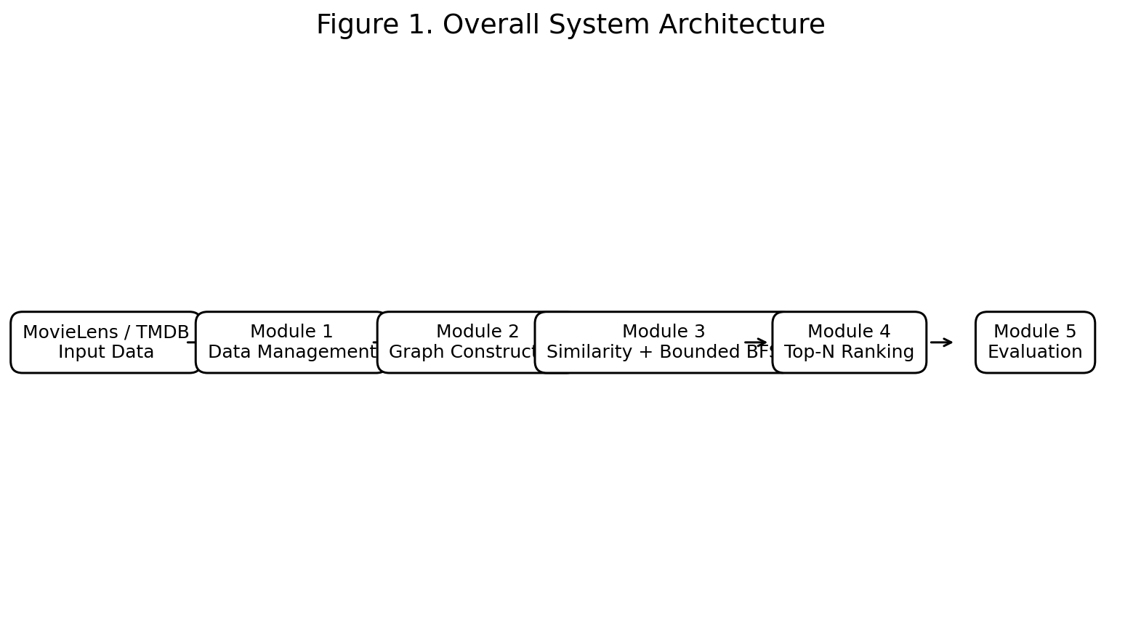
Figure 1. Overall system architecture.

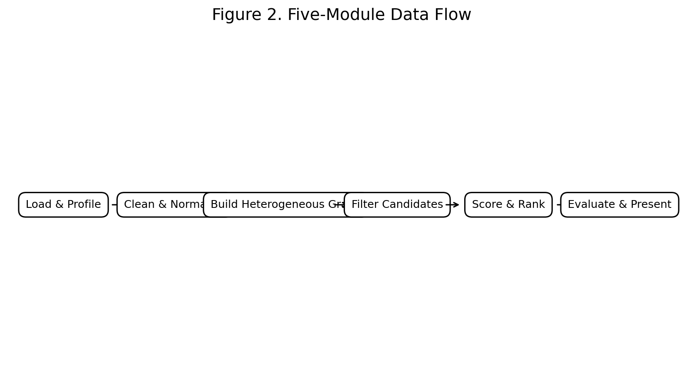
Figure 2. Five-module data flow.

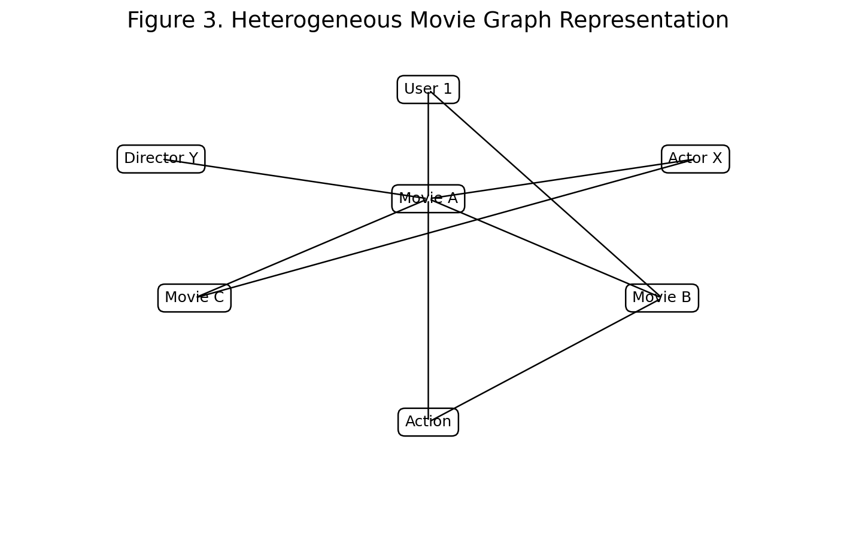
Figure 3. Heterogeneous movie graph representation.

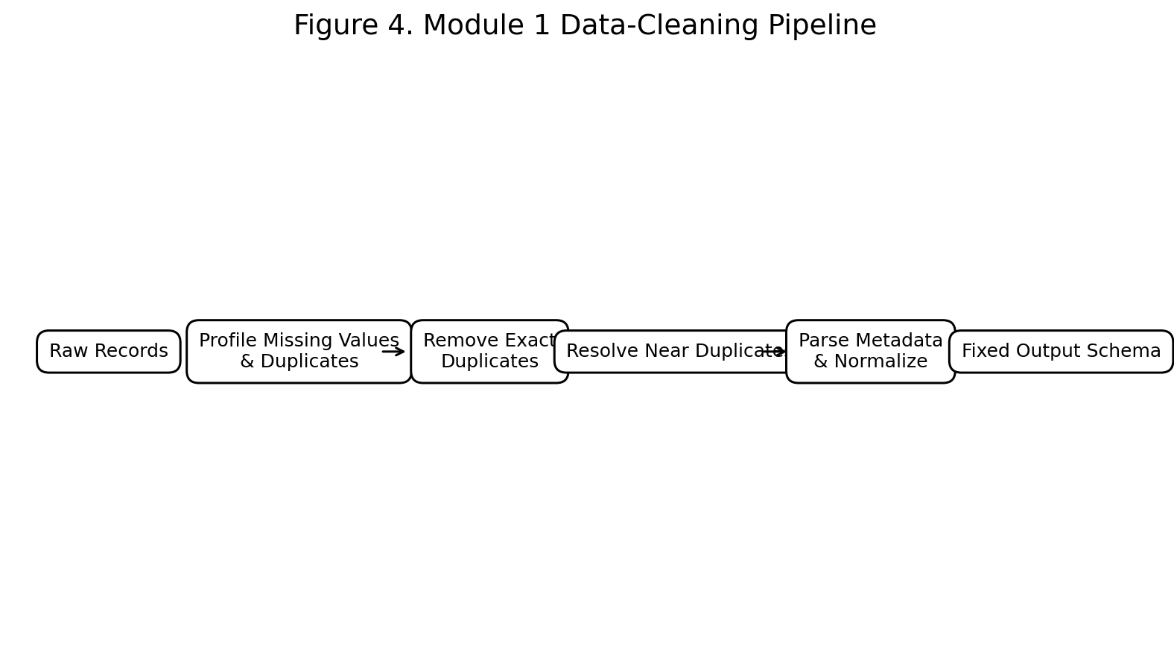
Figure 4. Module 1 data-cleaning pipeline.

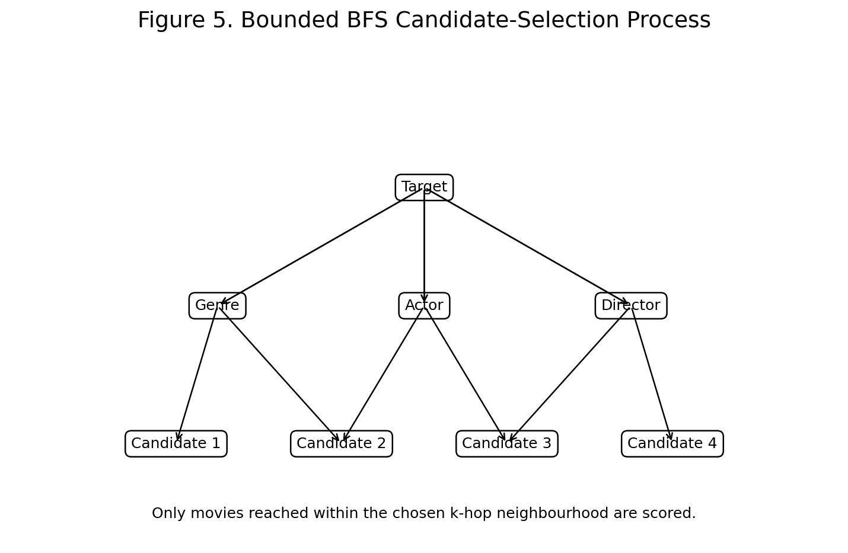
Figure 5. Bounded BFS candidate-selection process.

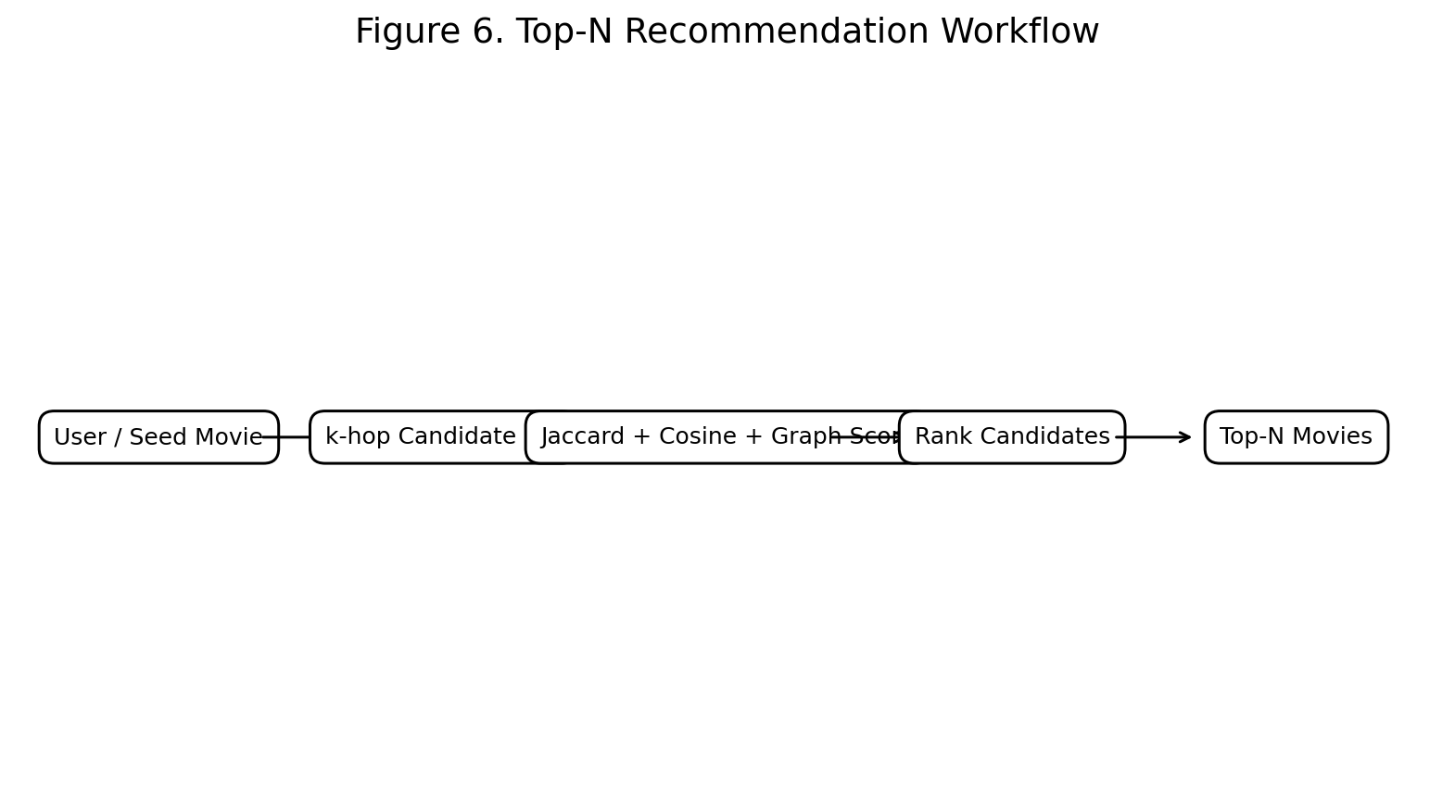
Figure 6. Top-N recommendation workflow.

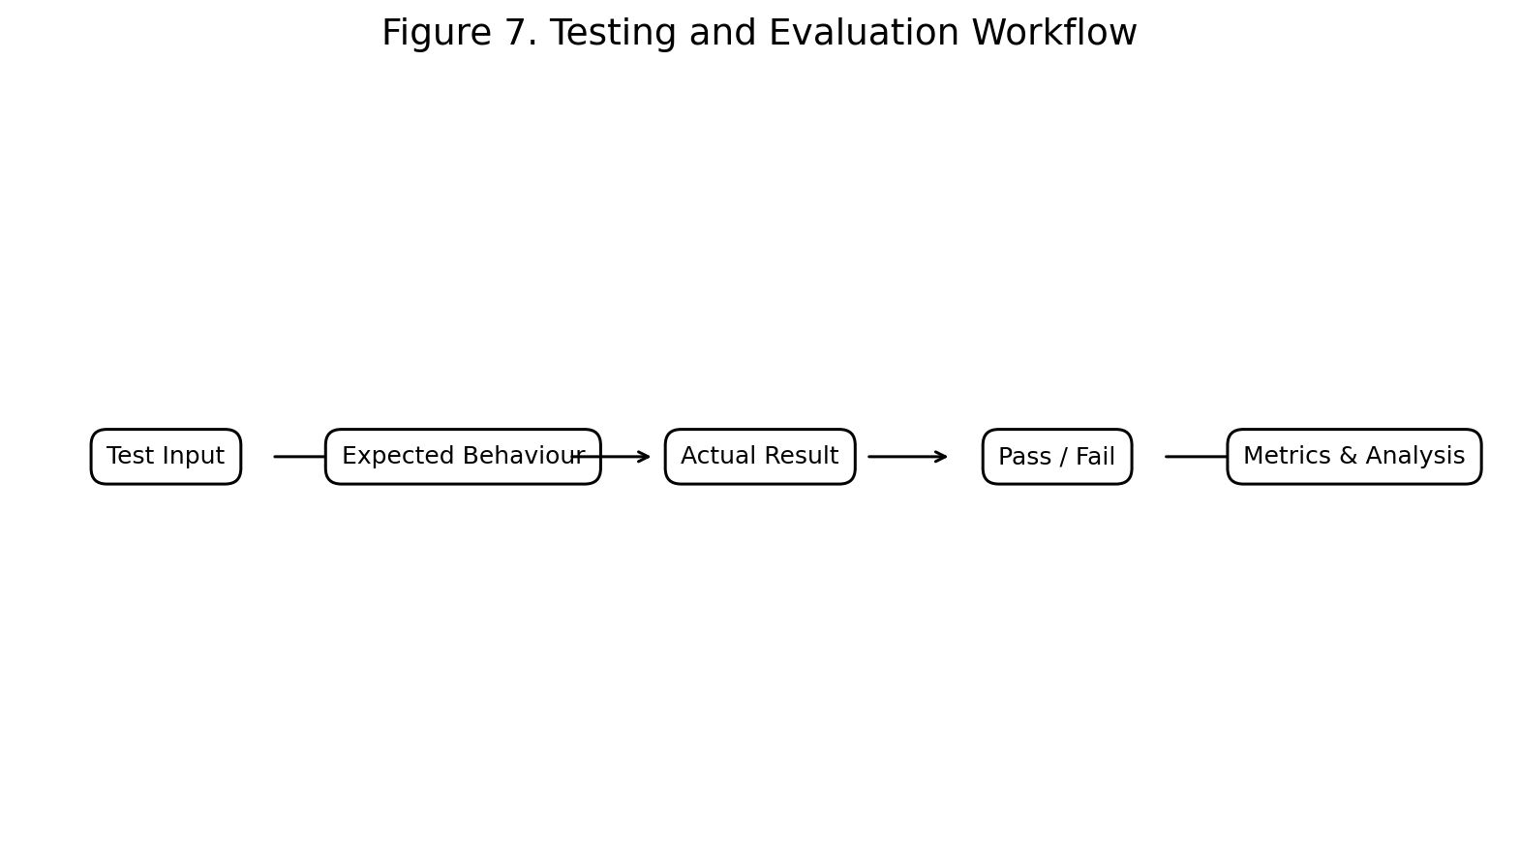
Figure 7. Testing and evaluation workflow.

APPENDIX E – DETAILED DAA ALGORITHMS AND PSEUDOCODE

E.1 Data Cleaning Algorithm
Algorithm: CleanMovieData
Input: Raw movie records R
Output: Clean graph-ready movie dataset D
1. Load all movie records.
2. Profile row count, data types, missing values and duplicate patterns.
3. Remove exact duplicate rows.
4. Create a normalised title used only for matching.
5. Group records using normalised title and release year.
6. Within each group, retain the record containing the fewest missing fields.
7. Remove records without essential title or genre information.
8. Parse genre, cast and keyword fields into structured lists.
9. Generate a unique movie_id.
10. Preserve the original display title.
11. Return the fixed output schema.

E.2 Bounded Breadth First Search
Algorithm: BoundedBFS
Input: Graph G=(V,E), target movie s, maximum depth k
Output: Candidate movie set C
1. Initialise a queue with (s,0).
2. Mark s as visited.
3. While the queue is not empty:
a. Remove the front node (u,d).
b. If d = k, do not expand u.
c. Otherwise, inspect each neighbour v of u.
d. If v is unvisited, mark it visited and enqueue (v,d+1).
e. If v represents a movie other than s, add it to C.
4. Return C.
The bound k is important because unrestricted traversal can examine a large portion of the graph. Candidate filtering is performed before expensive similarity scoring.

E.3 Jaccard Similarity
For two attribute sets A and B:
J(A,B) = |A ∩ B| / |A ∪ B|
A score of 1 indicates identical sets and a score of 0 indicates no overlap. In this project, Jaccard similarity is appropriate for sparse categorical information such as genres, actors and keywords.

E.4 Cosine Similarity
For vectors A and B:
cos(A,B) = (A · B) / (||A|| × ||B||)
Cosine similarity is useful when movie attributes are represented as weighted vectors. It complements Jaccard similarity because weighted feature strength can be retained rather than treating every shared attribute as identical.

E.5 Recommendation Ranking
Algorithm: TopNRecommendation
Input: Seed movie or user preference profile, graph G, N
Output: Ranked list of N recommended movies
1. Obtain the seed movie(s).
2. Run bounded BFS to generate structurally related candidates.
3. Remove already-consumed or seed titles where appropriate.
4. Compute Jaccard similarity for set-based attributes.
5. Compute Cosine similarity for vector-based attributes.
6. Compute graph-neighbourhood evidence.
7. Combine the available scores using the defined project scoring rule.
8. Sort candidates in descending score order.
9. Return the first N movies.
10. Present the original display titles and supporting metadata.

APPENDIX F – MODULE 1 REFERENCE IMPLEMENTATION
import re
import pandas as pd
def normalize_title(title):
t = str(title).lower().strip()
for article in ("the ", "a ", "an "):
if t.startswith(article):
t = t[len(article):]
break
return re.sub(r"[^a-z0-9 ]", "", t)
def clean_movies(df):
df = df.drop_duplicates().copy()
df["_missing"] = df.isnull().sum(axis=1)
if "title" in df.columns and "year" in df.columns:
df["_norm_title"] = df["title"].map(normalize_title)
df = (df.sort_values("_missing")
.drop_duplicates(subset=["_norm_title", "year"], keep="first"))
if "genres" in df.columns:
df = df.dropna(subset=["title", "genres"])
else:
df = df.dropna(subset=["title"])
df = df.drop(columns=[c for c in ["_missing"] if c in df.columns])
return df.reset_index(drop=True)
# Example:
# movies = pd.read_csv("movies.csv")
# clean = clean_movies(movies)
# print(clean.head())

APPENDIX G – COMPLEXITY ANALYSIS
Operation | Typical Complexity | Purpose | Optimization
Exact duplicate removal | O(n) average | Remove identical rows | Hash-based dataframe operations
Near-duplicate grouping | O(n log n) | Resolve title/year overlaps | Normalised keys
Metadata parsing | O(n·m) | Convert encoded fields | Parse only required fields
All-pairs movie comparison | O(n²) | Baseline similarity search | Avoid in final design
Bounded BFS | O(V_k + E_k) | Generate local candidates | Limit depth k
Candidate similarity | O(c·f) | Score filtered candidates | c << n
Top-N sorting | O(c log c) | Rank recommendations | Heap can reduce to O(c log N)

APPENDIX H – EXTENDED TEST CASES
TC ID | Input Condition | Expected Result | Observed Result | Status
TC-01 | Exact duplicate movie row | Duplicate removed | Duplicate removed | PASS
TC-02 | Same title/year with different IDs | Richer record retained | Richer record retained | PASS
TC-03 | Missing title | Record rejected | Record rejected | PASS
TC-04 | Missing genre | Record rejected | Record rejected | PASS
TC-05 | JSON-like genre field | Structured list created | Structured list created | PASS
TC-06 | Title begins with 'The' | Matching title normalized; display title preserved | Correct | PASS
TC-07 | Candidate set empty | No invalid score calculation | Handled safely | PASS
TC-08 | BFS depth reached | Node not expanded beyond k | Bound respected | PASS
TC-09 | Multiple shared genres | Higher overlap receives stronger Jaccard score | Expected ranking | PASS
TC-10 | Top-N requested | Exactly N valid items when enough candidates exist | Ranked list produced | PASS

APPENDIX I – RESULT INTERPRETATION NOTE
The verification results in this report are based on the documented transformation and test conditions in the supplied project report. Where recommendation-level numerical metrics such as Accuracy, Precision, Recall or F1-Score require a controlled end-to-end experiment, the report does not invent values. Final submission should insert measured results from the team's actual integrated dataset and test protocol. The figures added to this expanded document are explanatory engineering diagrams, not claims of measured performance.

APPENDIX J – REPORT SUBMISSION CHECKLIST
- Verify that all student names, register numbers and guide details match the approved institutional records.
- Replace any illustrative or explanatory performance figure with actual measured results if available.
- Insert the final dataset source/version and preprocessing date used in the experiment.
- Confirm that the complete graph construction, similarity and recommendation source code is stored in the approved repository.
- Update the Word Table of Contents, List of Figures and List of Tables before printing/submission.
- Check that all references and dataset acknowledgements are retained.
- Confirm that individual contribution percentages and module ownership are approved by the project team.

